WEEK 2 TASK
Advanced Data Visualization and Storytelling with Python

Titanic Passenger Dataset

Tools: Python • Pandas • Matplotlib • Seaborn • Jupyter Notebook
Student Name: Sharanya A
Internship: Data Science Internship
Week: 2

1. Introduction
Week 2 focuses on advanced data visualization and storytelling with Python. Building on the cleaned Titanic dataset prepared during Week 1, this project explores several variables simultaneously to move beyond basic descriptive charts. The objective is to communicate patterns clearly to a non-technical audience and demonstrate how visualization choices can turn numerical results into an understandable data story.
Five visualizations were developed using Seaborn and Matplotlib. They examine the combined relationship of gender and passenger class with survival, age distributions by survival status, the relationship between age and fare while encoding survival and passenger class, survival across family sizes, and a gender-by-class survival heatmap. Each visualization is accompanied by an interpretation and explains how it contributes to the overall narrative.

2. Objectives
- Create at least five advanced and meaningful visualizations.
- Explore interactions between multiple variables rather than analyzing variables independently.
- Use appropriate chart types for comparisons, distributions, relationships, and matrices.
- Create a coherent visual narrative around passenger survival.
- Identify patterns, differences, and potential anomalies.
- Discuss business or scientific implications and limitations of the observed patterns.

3. Dataset and Methodology
The analysis uses the cleaned Titanic dataset from Week 1. The cleaned data were loaded into Pandas and visualized with Seaborn and Matplotlib. A new feature, family_size, was engineered from sibsp and parch to support an additional survival analysis.
import pandas as pd
import numpy as np
import matplotlib.pyplot as plt
import seaborn as sns
df = pd.read_csv("titanic_cleaned.csv")
sns.set_theme(style="whitegrid")
The family_size feature was calculated as the number of siblings/spouses plus the number of parents/children, plus one for the passenger themselves.
df["family_size"] = df["sibsp"] + df["parch"] + 1

4. Visualization 1 – Survival Rate by Passenger Class and Gender
plt.figure(figsize=(10, 6))
sns.barplot(data=df, x="pclass", y="survived", hue="sex")
plt.title("Survival Rate by Passenger Class and Gender")
plt.xlabel("Passenger Class")
plt.ylabel("Survival Rate")
plt.ylim(0, 1)
plt.show()
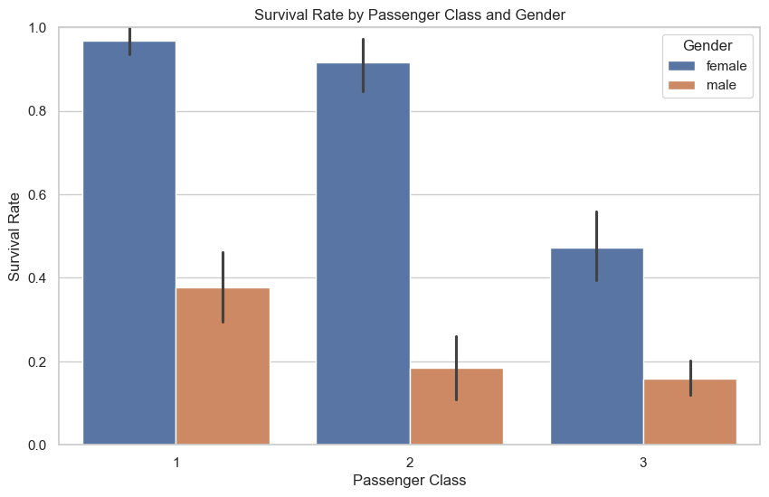
Figure 1. Survival Rate by Passenger Class and Gender.
This grouped bar chart combines two important categorical variables—gender and passenger class—to reveal a clear interaction in survival outcomes. Female passengers had higher survival rates in all three classes. The strongest observed rate was for females in first class at 96.77%, while the lowest was for males in third class at 15.88%. Female survival was 91.67% in second class and 47.24% in third class. Male survival was 37.82% in first class and 18.48% in second class.
Why this visualization helps the story: A single chart communicates that gender and class should not be considered in isolation. It highlights the combined pattern more effectively than two separate charts.

5. Visualization 2 – Age Distribution by Survival Status
plt.figure(figsize=(10, 6))
sns.histplot(data=df, x="age", hue="alive", bins=30, kde=True, element="step")
plt.title("Age Distribution by Survival Status")
plt.xlabel("Age")
plt.ylabel("Number of Passengers")
plt.show()
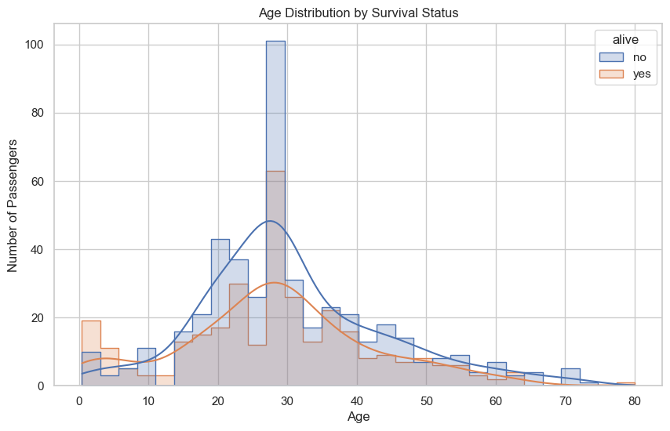
Figure 2. Age Distribution by Survival Status.
The overlapping distributions show that both survivors and non-survivors are concentrated largely in the young-adult and adult age ranges. The average age of survivors was 28.33 years, compared with 30.50 years for non-survivors. This relatively small difference suggests that age alone does not visually separate the two groups as strongly as gender or passenger class.
Why this visualization helps the story: The histogram and density curves show the shape of the distributions, rather than reducing age to only a single average. This helps the audience see where passengers of different survival outcomes were concentrated.

6. Visualization 3 – Relationship Between Age, Fare and Survival
plt.figure(figsize=(10, 6))
sns.scatterplot(
data=df, x="age", y="fare", hue="alive", size="pclass", alpha=0.7
)
plt.title("Relationship Between Age, Fare and Survival")
plt.xlabel("Age")
plt.ylabel("Fare")
plt.show()
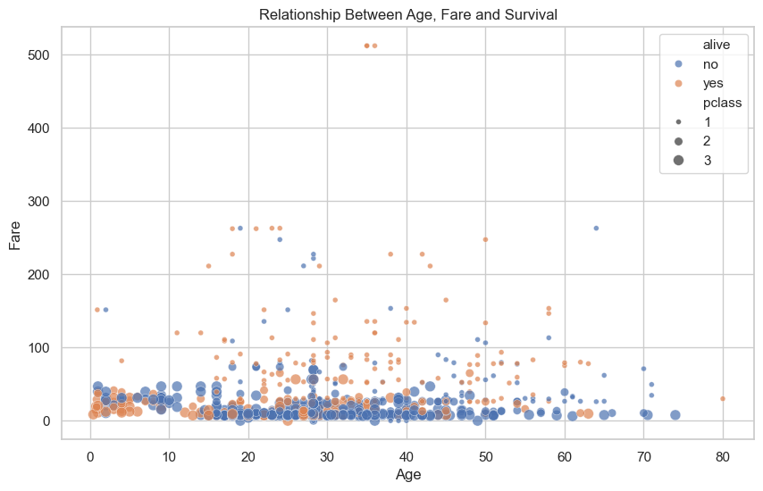
Figure 3. Relationship Between Age, Fare and Survival.
This scatter plot uses multiple visual encodings. Age is represented on the x-axis, fare on the y-axis, survival status by point color, and passenger class by point size. The plot shows that most observations are clustered at relatively low fares, while a smaller number of passengers paid substantially higher fares. Survivors had an average fare of 50.19, compared with 24.03 for non-survivors.
Why this visualization helps the story: It allows several dimensions to be examined simultaneously and makes high-fare observations visible. It also suggests that passenger class and fare may be connected to survival, which can be explored more formally in later statistical or machine-learning work.

7. Visualization 4 – Survival Rate by Family Size
plt.figure(figsize=(10, 6))
sns.barplot(data=df, x="family_size", y="survived")
plt.title("Survival Rate by Family Size")
plt.xlabel("Family Size")
plt.ylabel("Survival Rate")
plt.ylim(0, 1)
plt.show()
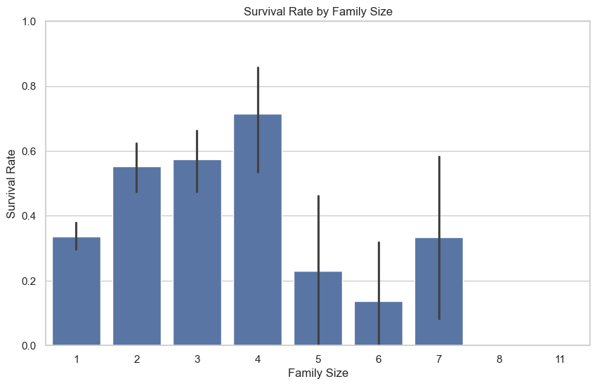
Figure 4. Survival Rate by Family Size.
The family-size analysis reveals a non-linear pattern. The observed survival rate increased from 33.71% for passengers travelling alone to 55.19% for family size 2, 57.43% for size 3, and a peak of 71.43% for size 4. The rate then dropped to 23.08% for size 5 and 13.64% for size 6. Family sizes 8 and 11 showed 0% survival.
The very large family groups should be interpreted cautiously because they contain few observations, making their rates less stable. This visualization is valuable because it introduces a derived feature and demonstrates that relationships in real-world data are not necessarily linear.

8. Visualization 5 – Survival Rate by Gender and Passenger Class Heatmap
survival_heatmap = pd.pivot_table(
df, values="survived", index="sex", columns="pclass", aggfunc="mean"
)
plt.figure(figsize=(8, 5))
sns.heatmap(survival_heatmap, annot=True, fmt=".2f", cmap="YlGnBu")
plt.title("Survival Rate by Gender and Passenger Class")
plt.xlabel("Passenger Class")
plt.ylabel("Gender")
plt.show()
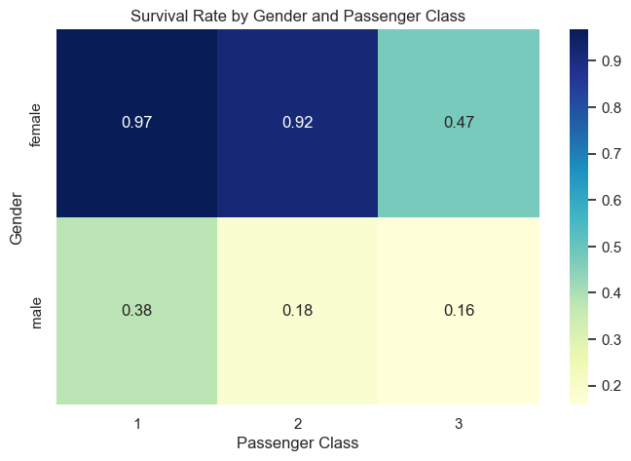
Figure 5. Survival Rate by Gender and Passenger Class.
The heatmap provides a compact summary of the interaction between gender and class. The darkest/highest-value cell corresponds to females in first class, with a survival rate of 0.97 (96.77%). The lowest cell corresponds to males in third class, with a survival rate of 0.16 (15.88%). Female passengers in second class had a rate of 0.92, while females in third class had 0.47. Male passengers in first and second class had 0.38 and 0.18, respectively.
Why this visualization helps the story: The color intensity makes the strongest and weakest combinations easy to identify immediately, making the interaction pattern accessible to a non-technical audience.

9. Summary of Key Results
Analysis | Result | Interpretation
Female, 1st class | 96.77% survival | Highest observed group survival
Male, 3rd class | 15.88% survival | Lowest observed group survival
Family size 4 | 71.43% survival | Highest observed family-size rate
Survivor average fare | 50.19 | Higher than non-survivor average
Non-survivor average fare | 24.03 | Lower than survivor average
Survivor average age | 28.33 years | Slightly lower than non-survivors
Non-survivor average age | 30.50 years | Difference from survivors is modest

10. Data Story
The five visualizations tell a consistent story about passenger survival. The strongest differences appear when gender and passenger class are considered together: women generally had higher observed survival rates, and first-class passengers generally had better outcomes. The heatmap makes this pattern especially clear.
The age distribution adds nuance. Survivors were slightly younger on average, but the overlapping age distributions show that age alone does not create a sharp separation between the groups. Fare provides another important dimension: survivors paid substantially higher fares on average. Since fare is related to ticket class, this pattern is consistent with the class-related survival differences.
Finally, family size reveals a non-linear relationship. Medium-sized families in this dataset, especially family size 4, had relatively high observed survival, while very large family groups had low observed rates. Because some large family-size categories contain few observations, they should not be treated as definitive conclusions.

11. Business and Scientific Implications
- For scientific analysis, the strong differences by gender and passenger class suggest that these variables should be included in subsequent hypothesis testing and predictive models.
- The fare pattern indicates that economic or class-related factors may be useful explanatory variables when studying survival outcomes.
- The family-size pattern suggests that social-group structure may contain additional predictive information, but rare group sizes require careful treatment.
- For non-technical audiences, combined charts such as the heatmap can communicate complex interactions more effectively than tables of numbers.
- These findings should be treated as associations in a historical dataset rather than causal evidence.

12. Limitations
- Some family-size categories have very few observations, so their survival percentages can be unstable.
- The scatter plot contains many observations in the lower-fare region, which can make individual points overlap.
- Visualization alone cannot establish causation or statistical significance.
- The Titanic dataset represents a historical population and may not generalize to modern settings.
- Passenger class and fare are related, so their effects should be separated carefully in later analyses.

13. Future Analysis
- Use statistical hypothesis testing to determine whether observed survival differences are statistically significant.
- Examine interactions between gender, passenger class, and family size.
- Use logistic regression or tree-based models to predict survival.
- Evaluate model performance using accuracy, precision, recall, F1-score, ROC-AUC, and confusion matrices.
- Investigate whether engineered features such as family size improve predictive performance.

14. Conclusion
Week 2 successfully extended the Week 1 analysis from basic exploratory charts to advanced visualization and data storytelling. Five visualizations were created to examine interactions, distributions, multivariable relationships, derived features, and matrix-style comparisons.
The visual story indicates that gender and passenger class are strongly associated with observed survival outcomes. Female first-class passengers had the highest observed survival rate at 96.77%, while male third-class passengers had the lowest at 15.88%. Survivors also had a higher average fare than non-survivors, while their average age was slightly lower. Family size showed a non-linear pattern, with size 4 having the highest observed survival rate but rare large family groups showing unstable low rates.
Overall, the project demonstrates how thoughtful visualization can make complex patterns easier to understand and provides a strong foundation for the statistical analysis and machine-learning tasks planned for Weeks 3 and 4.

15. References
1. Seaborn documentation – statistical visualization and Titanic dataset interface.
2. Pandas documentation – DataFrame manipulation, grouping, pivot tables, and feature engineering.
3. Matplotlib documentation – figure creation, labels, titles, and plot customization.

